PROMISE & PRACTICE · DEEP DIVE · SOURCE ANALYSIS
The 13th Amendment — A House Divided
Freedom, Written Into the Constitution
Name: ______________________________ Period: _____ Date: ________________
WHAT I CAN DO TODAY I can read primary sources about The 13th Amendment — A House Divided, weigh who made each one and why, and use evidence to answer historical questions.
Directions. A few lines of text changed the country. Read them closely — what they do, and what they leave open

THE SOURCES
SOURCE · THE THIRTEENTH AMENDMENT · RATIFIED 1865 — The full text
Section 1. Neither slavery nor involuntary servitude, except as a punishment for crime whereof the party shall have been duly convicted, shall exist within the United States, or any place subject to their jurisdiction. Section 2. Congress shall have power to enforce this article by appropriate legislation.
— U.S. Constitution, Amendment XIII. Public domain
— U.S. Constitution, Amendment XIII. Public domain.
THE IMAGE · 1865 — “The Triumph of Freedom over Slavery”
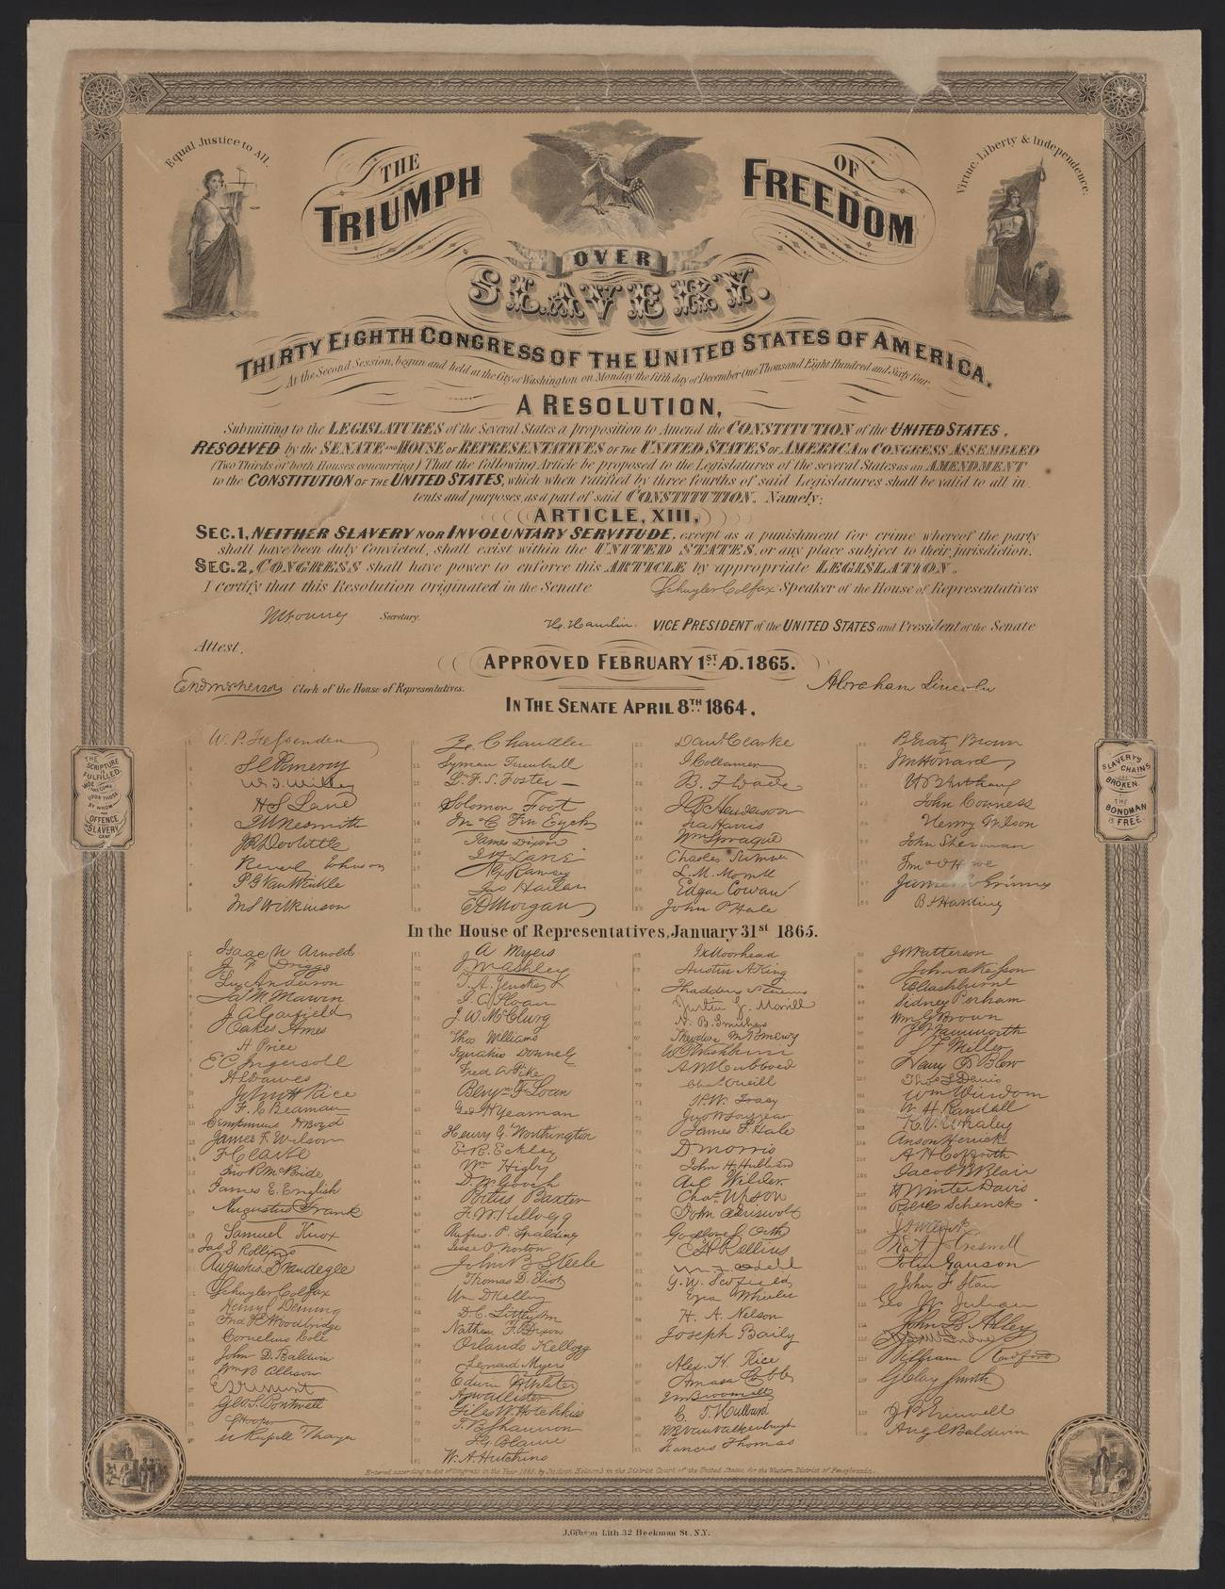
“The Triumph of Freedom over Slavery” — print with the text of the Thirteenth Amendment and the roll of ayes, public domain (Library of Congress).

YOUR WORK
QUESTION 1 STEP 1 · PROCLAMATION VS. AMENDMENT
The Emancipation Proclamation had already freed many enslaved people. Why was a constitutional amendment still necessary to end slavery? (Think about what a “war measure” could and couldn't do.)
____________________________________________________________________________________________
____________________________________________________________________________________________
____________________________________________________________________________________________
QUESTION 2 STEP 2 · READ THE FINE PRINT
Section 1 abolishes slavery “except as a punishment for crime.” How was this clause later misused?
☐ A. it freed more people than intended
☐ B. states used unjust arrests to force Black Southerners into convict labor
☐ C. it abolished all prisons
☐ D. it had no effect at all
QUESTION 3 STEP 3 · WHAT SECTION 2 ADDS
Section 2 gives Congress the power to enforce the amendment “by appropriate legislation.” Why was it important to include that power, rather than just declaring slavery illegal?
____________________________________________________________________________________________
____________________________________________________________________________________________
____________________________________________________________________________________________
QUESTION 4 STEP 4 · WHY IT MATTERS
The Constitution once protected slavery; now it abolished it. In three or four sentences, explain why the Thirteenth Amendment is called part of a “second founding” of the United States — and weigh both its triumph and its one flaw.
____________________________________________________________________________________________
____________________________________________________________________________________________
____________________________________________________________________________________________
____________________________________________________________________________________________
____________________________________________________________________________________________
Promise & Practice · ShadowDog Digital Studios · Unit 2

TEACHER ANSWER KEY — The 13th Amendment — A House Divided

QUESTION 1: Open response.
Look for a response along the lines of: “The Proclamation was only a war measure, so…. An amendment was needed because…”
QUESTION 2: Correct — B. states used unjust arrests to force Black Southerners into convict labor
Right. Southern states used unjust arrests and convictions to force Black people into convict labor — exploiting the amendment's one exception. The loophole had lasting, painful consequences.
QUESTION 3: Open response.
Look for a response along the lines of: “Giving Congress enforcement power mattered because…”
QUESTION 4: Open response.
Look for a response along the lines of: “The 13th Amendment was a second founding because…, though its exception clause…”

